Community Care And Support Australia

Changes:
- Navbar too Empty After logo on desktop:
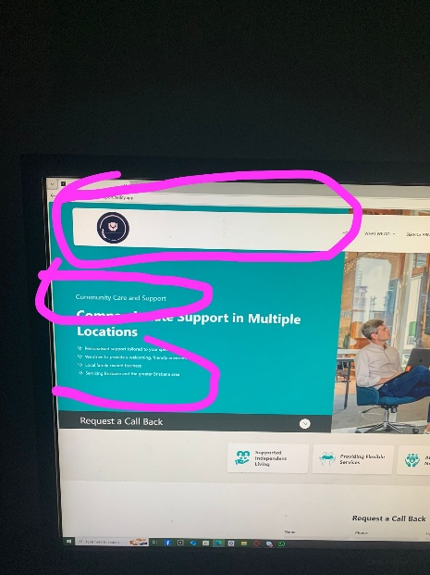

Company Full Name Inserted Right After the logo to make it look more Attractive and to fill the empty space

- Company Name Should be complete and Prominent (Bolder and Bigger):
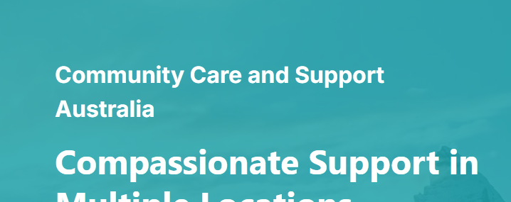
Company Name made Bolder and Made it Complete with the Suffix Australia

- Points in Hero Section Should be more Prominent:
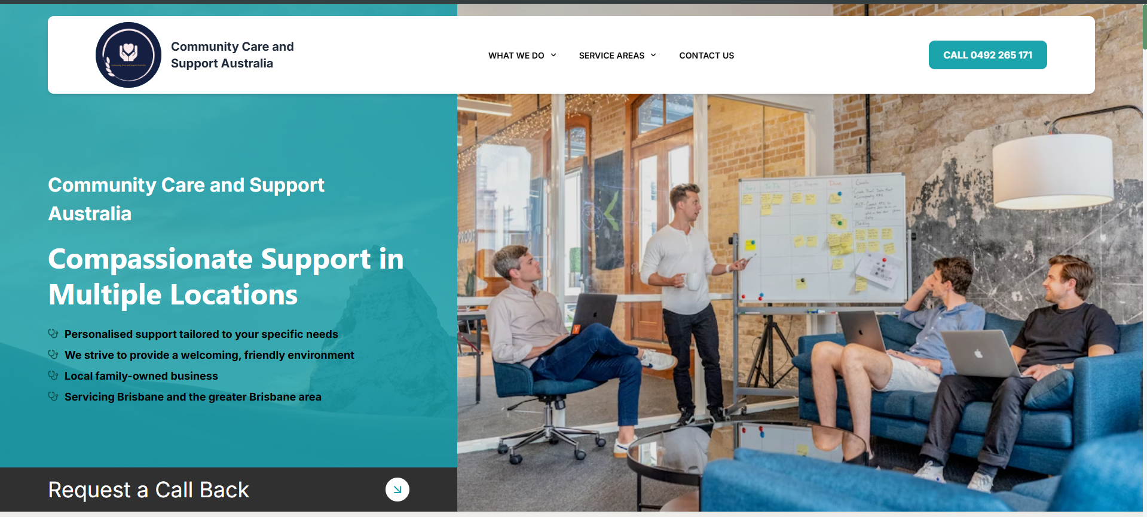
Points made bolder and the background image added to Left Section for more attraction and to make it pop

- Navbar Links to be bolder and more Visible
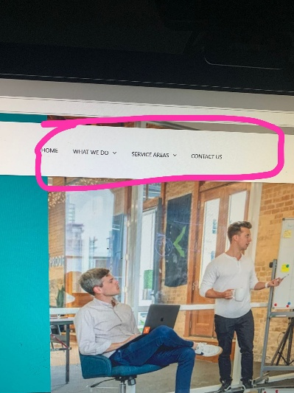
Navbar links made bolder and more Visible

- Adress Changings
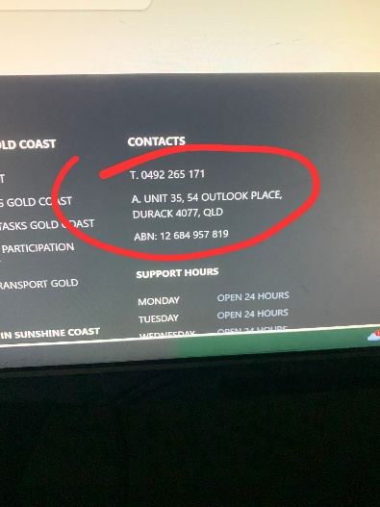 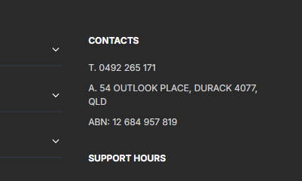
Address changes Everywhere on the site

- More Adress Changings
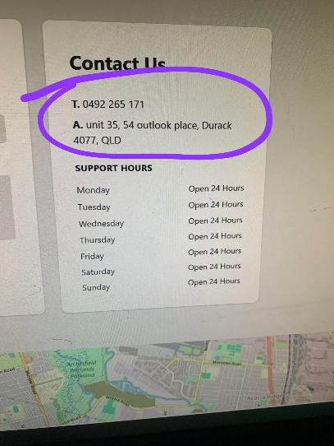 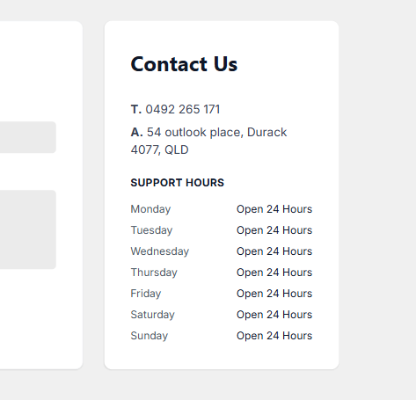
Contact info changes Everywhere on the site

- Contact Page Hero Section Improvment
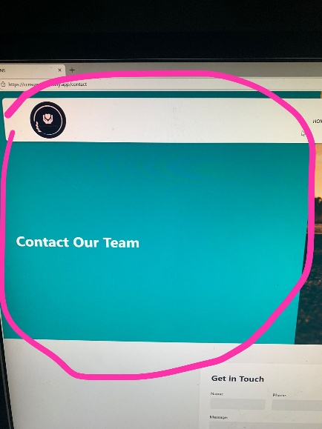
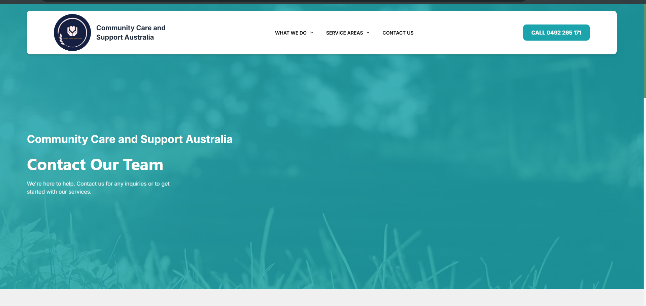
Improvements made to the Contact page Home Section

- Footer Section Logo Should be bigger and center of column
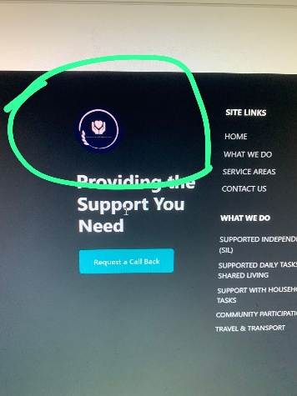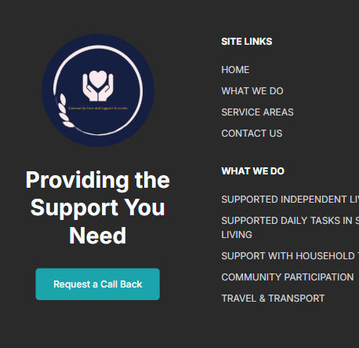

The Logo is made Bigger and the Column is set to Center

- Footer is Congested with links, We should Simplify the Footer
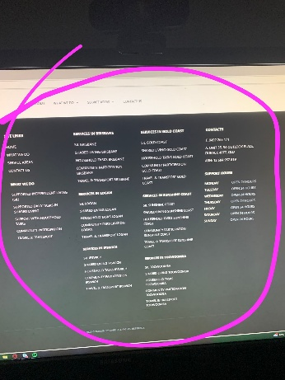 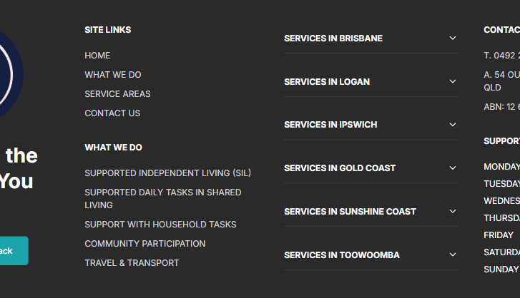
The Location links are put in a toggle list and all locations are put in a single column

